Food Delivery Management System – DB Project
Presented by Muhammad Abdullah and M Hassan Amir

1. Domain Understanding
The Food Delivery Management System is designed to streamline the process of ordering food online. Customers can place orders to restaurants via the application, and delivery personnel ensure orders reach the customers efficiently. This project involves implementing core DBMS concepts such as ER diagrams, normalization (up to 3NF), relational schema design, and SQL implementation.

2. Entities and Relationships
Entities:
- Customer
- Restaurant
- MenuItem
- Order
- OrderItem
- DeliveryPerson
- Delivery
- Payment
Relationships:
- A Customer can place multiple Orders.
- A Restaurant can offer multiple MenuItems.
- An Order can include multiple MenuItems (via OrderItem).
- An Order is fulfilled by a DeliveryPerson.
- A Restaurant can receive multiple Orders.
- Each Order has one associated Payment.
- A DeliveryPerson can handle multiple Deliveries.
- Each Order has one Payment.
3. ER Diagram
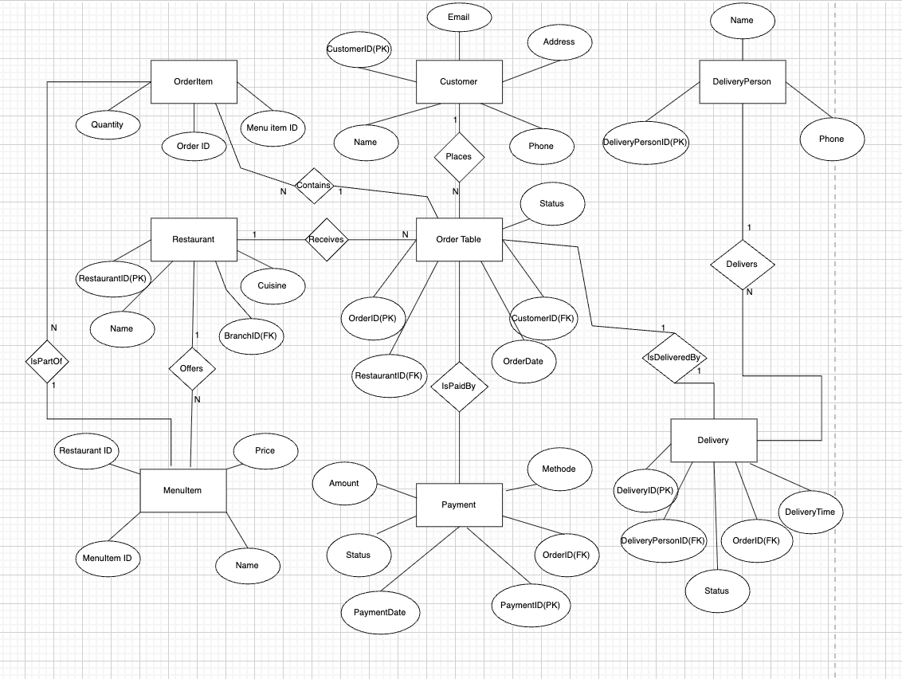

4. Relationship Schema

- Customer(CustomerID PK, Name, Email, Phone, Address)
- Restaurant(RestaurantID PK, Name, Cuisine, Address)
- MenuItem(MenuItemID PK, Name, Price, RestaurantID FK)
- Order(OrderID PK, CustomerID FK, RestaurantID FK, OrderDate, Status)
- OrderItem(OrderID FK, MenuItemID FK, Quantity) -- PK(OrderID, MenuItemID)
- DeliveryPerson(DeliveryPersonID PK, Name, Phone)
- Delivery(DeliveryID PK, OrderID FK, DeliveryPersonID FK, DeliveryTime, Status)
- Payment(PaymentID PK, OrderID FK, Amount, Method, Status, PaymentDate)

5.Food Delivery Management System – Tables and 3NF Normalization

Restaurant Table
RestaurantID | Name | Cuisine | BranchID
1 | Burger Palace | Fast Food | 1
2 | Sushi Zen | Japanese | 2

Customer Table
CustomerID | Name | Email | Phone | Address
1 | Ali Khan | ali@example.com | 03123456789 | Gulshan Block 3
2 | Sara Ahmed | sara@example.com | 0300123456 | DHA Phase 5

MenuItem Table
MenuItemID | Name | Price | RestaurantID
1 | Cheeseburger | 500 | 1
2 | Fries | 200 | 1
3 | Sushi Roll | 850 | 2

OrderTable
OrderID | CustomerID | RestaurantID | OrderDate | Status
101 | 1 | 1 | 2025-06-01 | Completed
102 | 2 | 2 | 2025-06-02 | Pending

OrderItem Table
OrderID | MenuItemID | Quantity
101 | 1 | 2
101 | 2 | 1

DeliveryPerson Table
DeliveryPersonID | Name | Phone
1 | Ahmed Ali | 03111222333
2 | Fatima Noor | 0300999888

Delivery Table
DeliveryID | OrderID | DeliveryPersonID | DeliveryTime | Status
1 | 101 | 1 | 2025-06-01 13:00:00 | Delivered
2 | 102 | 2 | 2025-06-02 15:30:00 | In Progress

Payment Table
PaymentID | OrderID | Amount | Method | Status | PaymentDate
1 | 101 | 1200 | Credit Card | Paid | 2025-06-01
2 | 102 | 2550 | Cash | Pending | 2025-06-02

6. Normalization Explanation

First Normal Form (1NF):
- All attributes contain atomic (indivisible) values.
- No repeating groups (e.g., MenuItems split into OrderItem table).

Second Normal Form (2NF):
- All non-key attributes are fully functionally dependent on the whole primary key.
- OrderItem has a composite key (OrderID, MenuItemID), and Quantity depends on both.

Third Normal Form (3NF):
- No transitive dependencies.
- Example: In MenuItem, restaurant details are not duplicated; only the foreign key RestaurantID is stored.

7. Conclusion
The Food Delivery Management System project demonstrates proper application of database concepts such as ER design, relational modeling, and normalization. By transforming all tables into 3NF, we ensure:
- Data consistency
- Elimination of redundancy
- Better integrity and scalability
The sample data, normalized schema, and logical design collectively replicate real-world food delivery workflows, making this project robust, efficient, and implementation-ready.

